**Submitted By: --**

**Name: -- Mannu Kumar**

**College: -- Lovely Professional University, Punjab**

**Reg. No.: -- 12204749**

**Course: -- MCA [Masters in Computer Applications]**

**Course Period: -- 2022-2024**

**Specilization: -- Web Development**

**Assignment Task: -- UI/UX Designing**

**Assigning Date: -- 07/12/2023**

**Submitted Date: -- 10/12/2023**

**Website Name: -- “Welcome to Tour” – releated to Tourism**

**Language Use: --HTML, CSS (Frontend Design)**

**Tools Use: -- VS-code**

**Submitted To: --**

**Name: -- Rupin Mathur**

**Co-founder QuadB Technologies**

**UX Design Task: -- You will create a user flow diagram for an application, showcasing your understanding of user navigation and experience.**

**Explanation: --**

**I am creating a website, named by “Welcome to Tour”. It is a website which is helpful to the tourist who wants to travel the India through the train, aeroplane, bus, car and so on. Also, this provides the hotel facilities to their own customers.**

**Welcome to Trip is a company that helps people plan and book amazing vacations. We work with a network of travel agents and suppliers to offer our clients the best possible deals on flights, hotels, activities, and more. We are passionate about travel and believe that everyone should have the opportunity to experience the world.**

**We offer a wide variety of services, including: --**

* **Flight booking**
* **Hotel booking**
* **Activity booking**
* **Car rental**
* **Travel insurance**
* **Visa assistance**

**We also offer several specialized travel packages, such as: --**

* **Honeymoon packages**
* **Family vacation packages**
* **Adventure vacation packages**
* **Luxury vacation packages**
* **Group travel packages**
* **Festival travel packages**

**We are committed to providing our clients with the highest quality of service. Our team of experienced travel agents is available 24/7 to answer your questions and help you plan your dream vacation.**

**Our website “Welcome to Trip” also offers: --**

* **Personalized travel recommendations**
* **24/7 customer support**
* **Secure online booking**
* **A user-friendly website**

**Our website provides some functionality that wise the customers choose their website: --**

* **We offer the best deals on flights, hotels, and activities.**
* **We have a network of travel agents and suppliers who can help you plan your dream vacation.**
* **We are passionate about travel and believe that everyone should have the opportunity to experience the world.**

**User Flow Diagram: --**

**Welcome To Trip**

**Contact with Owner of website, to give the feedback.**

**Articles related to new product and services.**

**Know About Company and website.**

**User-friendly Website**

**Customer Support**

**Car Rental**

**Different Packages**

**Hotel Booking**

**Flight Booking**

**The tourist place of India’s different state or city that will help to tourist to plan their vacation.**

**Contact Us**

**Blogs**

**About Us**

**Services**

**Tours**

**Home**

**Nav Bar**

**UI Design Task: -- Your task is to revamp the homepage of a given website, demonstrating your proficiency in visual design and responsiveness.**

**Explanation: --**

**I am sharing the screenshots of my website to revamp the homepage of website. The frontend is design by only HTML and CSS and make the website responsive, that will look like attractive into all platforms. To making responsive, I’m using media query.**

**The screenshots: --**

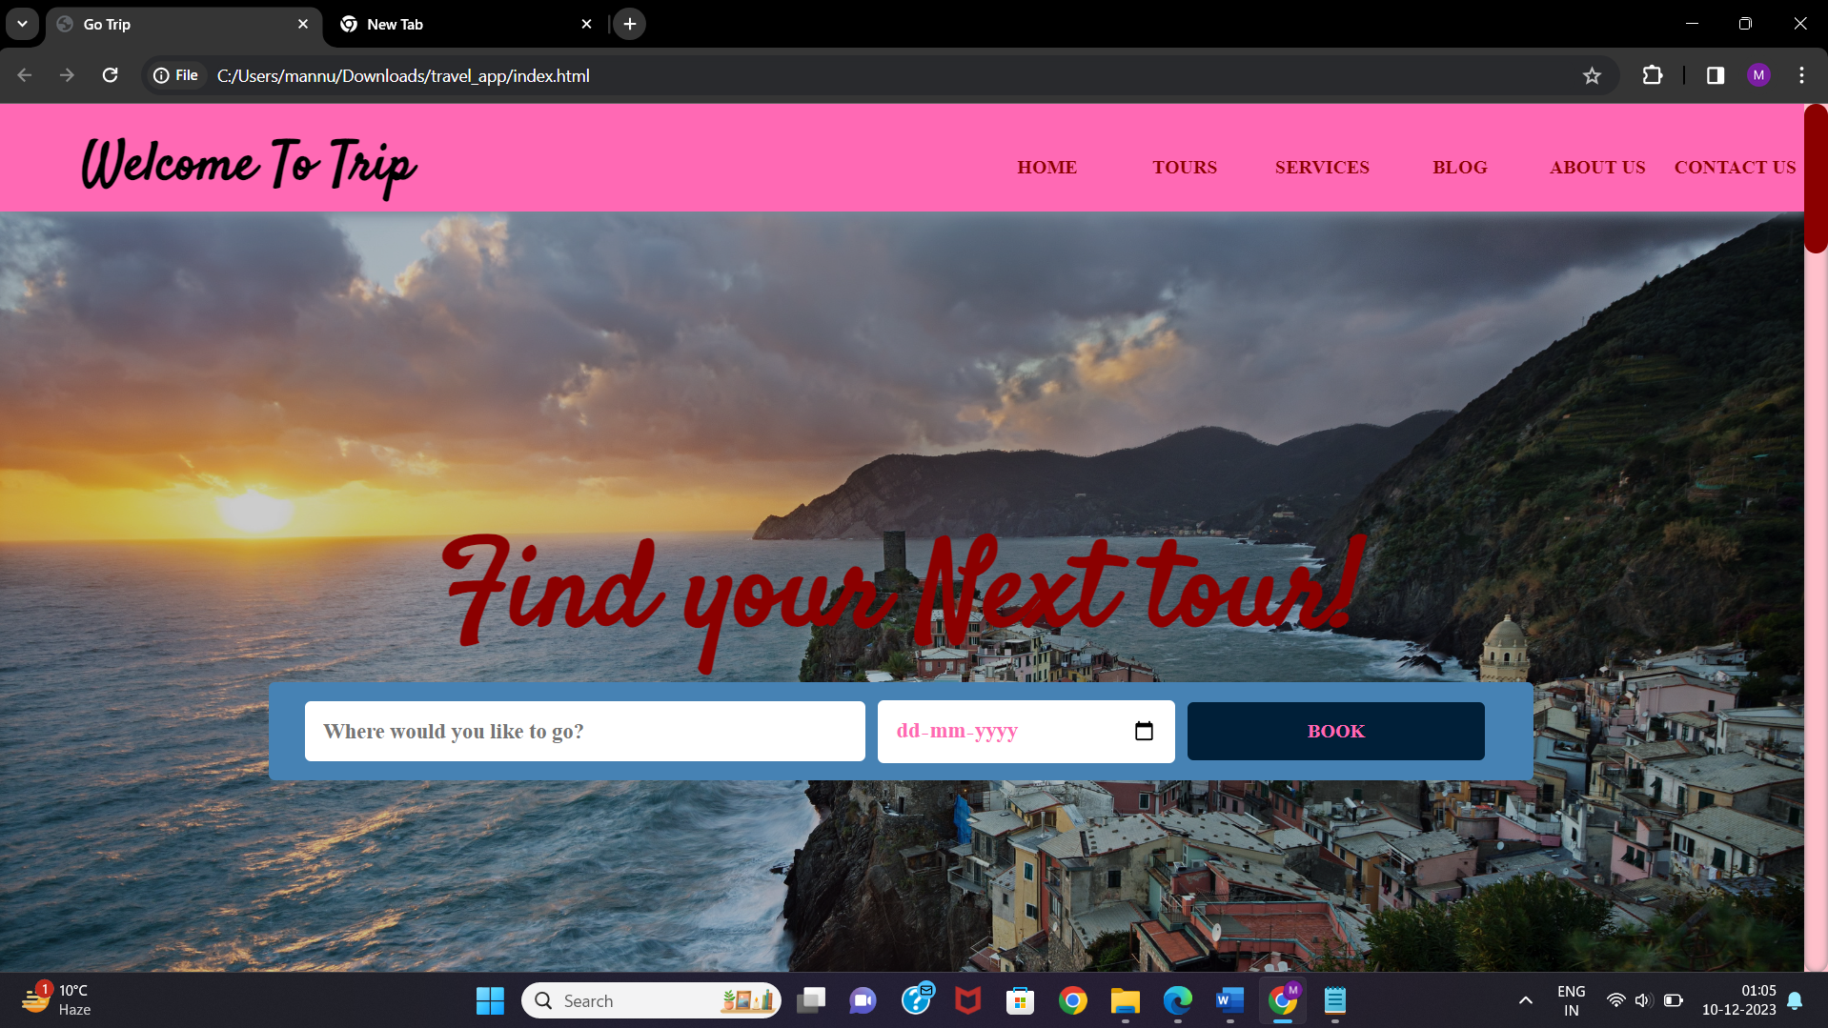

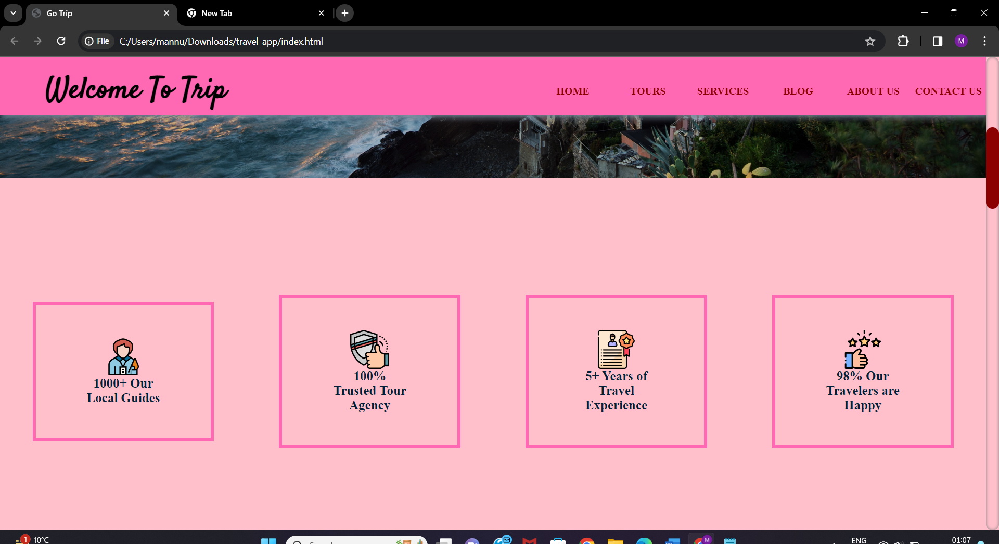

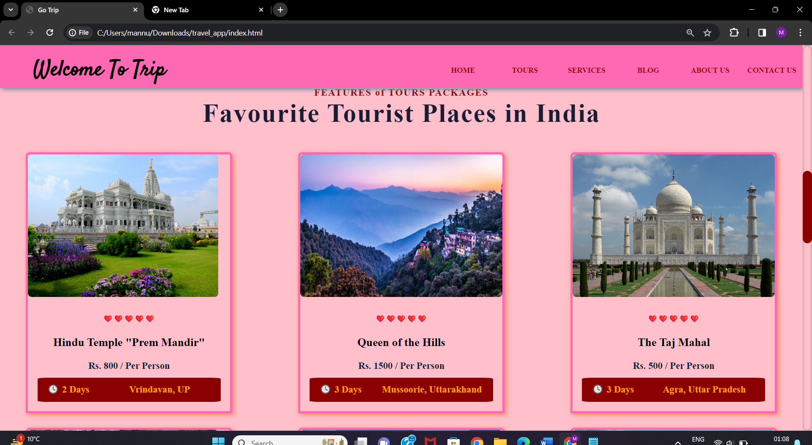

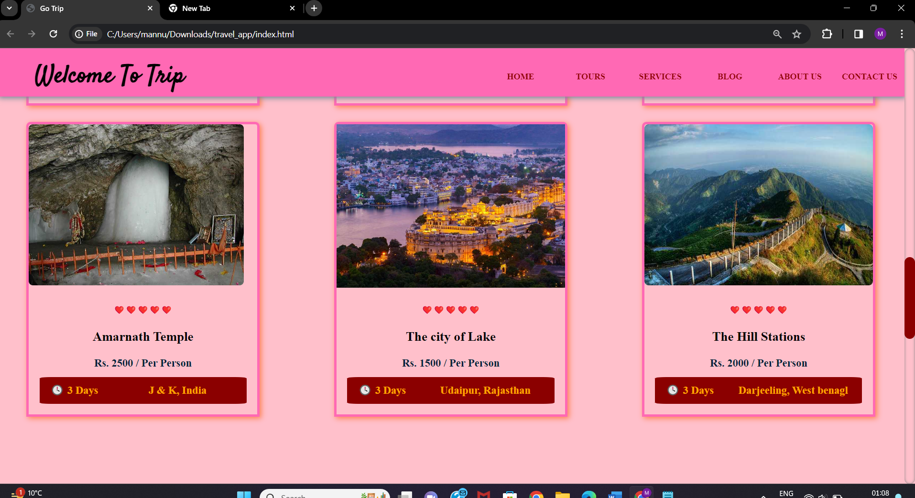

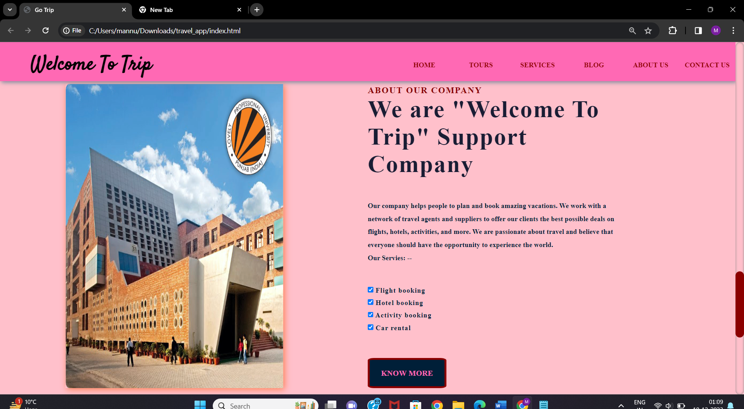

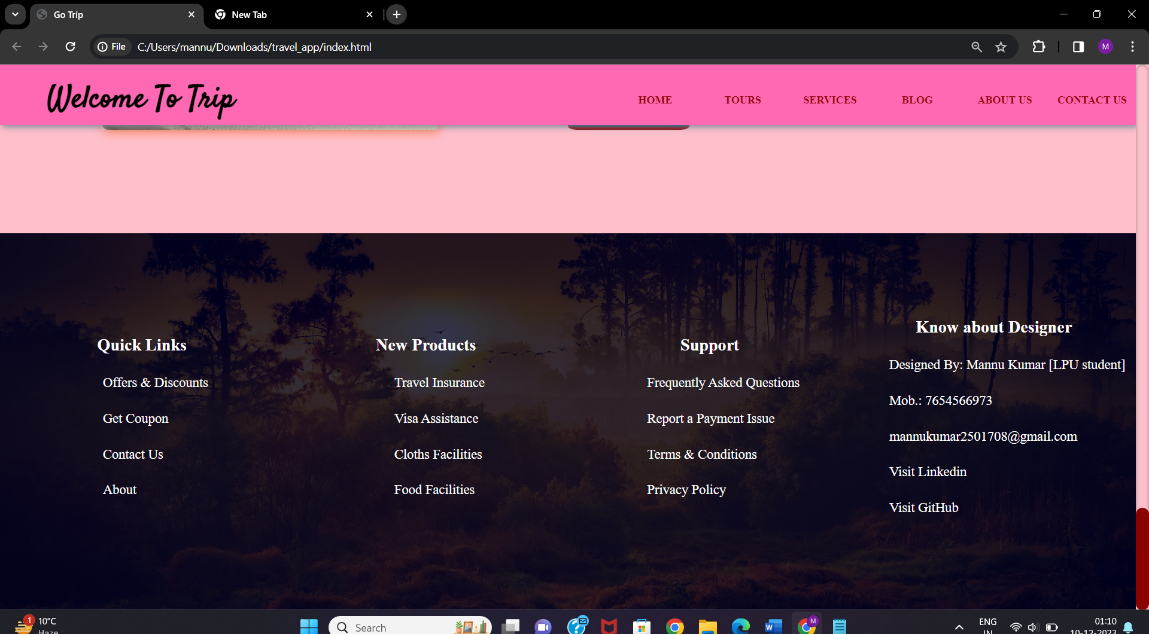

**To visit my GitHub, to show the code implementation of my website: --**

**https://github.com/Mannu7654/Travel_App-HTML-CSS/**

**Live the project: --**

**https://mannu7654.github.io/Travel_App-HTML-CSS/travel_app/index.html**

**Thank You.**